**Issue with construction of Report instances in Rule Actions**

In the rule action, **Report** object has to be created using **new** or **newUnique** with all attributes defined inline (except a single attribute which could be defined using **cellValue**). This may be OK (although not ideal) for objects that have 2 or 3 attributes, but for objects with many attributes a tabular approach would be much more maintainable and readable.

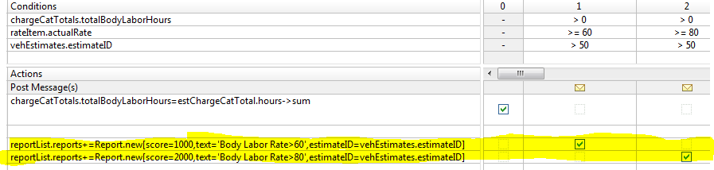

Solution:

Here’s one way to accomplish what you want

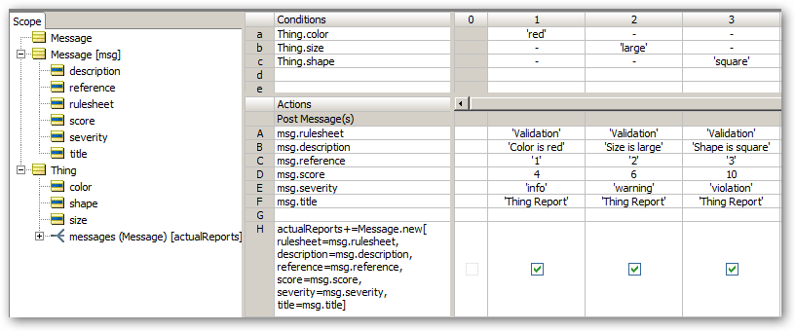

Or

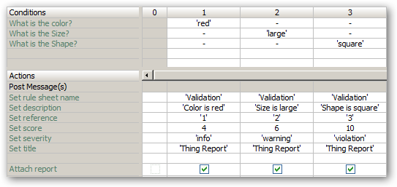

By supplying (or omitting) an empty “seed” instance ofMessage in the input payload you can control the generation of the messages:

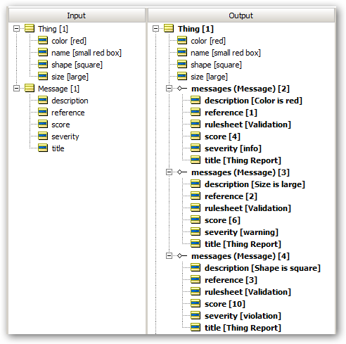

Any numberof additional attributes can be added to the Message object and set in the rule columns.

And because the messages are instances, it becomes possible to write rules that can analyse the messages. Eg counting different types, totalinq the score, merging similar messages etc

These messages can also be stored in a database

The final unattached message is the temporary one that contains the last settings used – it can be ignored.